Bird Barn

Subject:  Related Subjects: | Grade Level(s):  Length of Lesson: | Type: Inquiry / Design / Project  Keywords:

Lesson Overview
Use this section to describe at a high level what the lesson is. Should be no more than 3-4 lines.

Lesson Focus
What is the central question or phenomenon being investigated? What problem are they trying to solve?

Lesson Objective(s) | By the end of this lesson, students will…  - Learn the concepts of attraction, repulsion, friction, polarity, and charge.

Lesson Timing

5 minutes | Introduce the Lesson
30 minutes | ...

Materials
Instructor Prep | - Step 1
Related Resources | - List related lessons/ppts etc available from USC or outside, trusted orgs

Lesson Plan

Introduction
Introduce students to the learning goals and make connections to past and present learning experiences. Stimulate interest and prompt students to identify their own questions about the topic. This can link the lesson to real world examples, introduce associated STEM careers, and assess their prior knowledge on the topic.

- Step 1

Procedure
- Cut 2 ‐ 3" pieces of balsawood sticks
- Cut 2 ‐ 2 3/4" pieces of balsawood sticks
- Create a square by putting glue on the tops of the shorter pieces and attaching the longer pieces
- Repeat steps 1 ‐ 3
- Cut 4 ‐ 5 3/4" sticks
- Create a box by connecting the 2 ‐ 3" squares by attaching the 5 3/4" sticks beween them in the corners
- Cut 4‐ 3" pieces of balsawood sticks
- With two pieces, create a triangle and glue to the top on one end of the box (with the box laying lengthwise). The top part of the triangle should have a groove.
- Do the same for the other end of the box at the top (should look like the frame of a house
- Cut a 6" stick and connect the two triangels by laying the stick in the groves and glueing
- Divide the plank into 6 sections by drawing lines every 6"
- Score, (repeatedly trace with x‐acto knive) each of the drawn lines until the trench is as deep as possible
- Place plank on a flat surface with the scored side up
- Align the first line with the edge of the flat surface
- Gently break wood along scored line by pushing the board over the edige of the flat surface
- Repeat for remaining scored lines
- Glue 3 boards on the bottom of house and sides.
- Remove any excess glue or glue strands (so birds don't eat them)
- Measure score and break one of the 6" boards in half
- Glue on of the half board pieces on one end of the house (this becomes the back).
- Glue the top boards on to the top of the house
- Using the remaining half board, cut a triangle to cover the upper part of the back of the house and glue in place
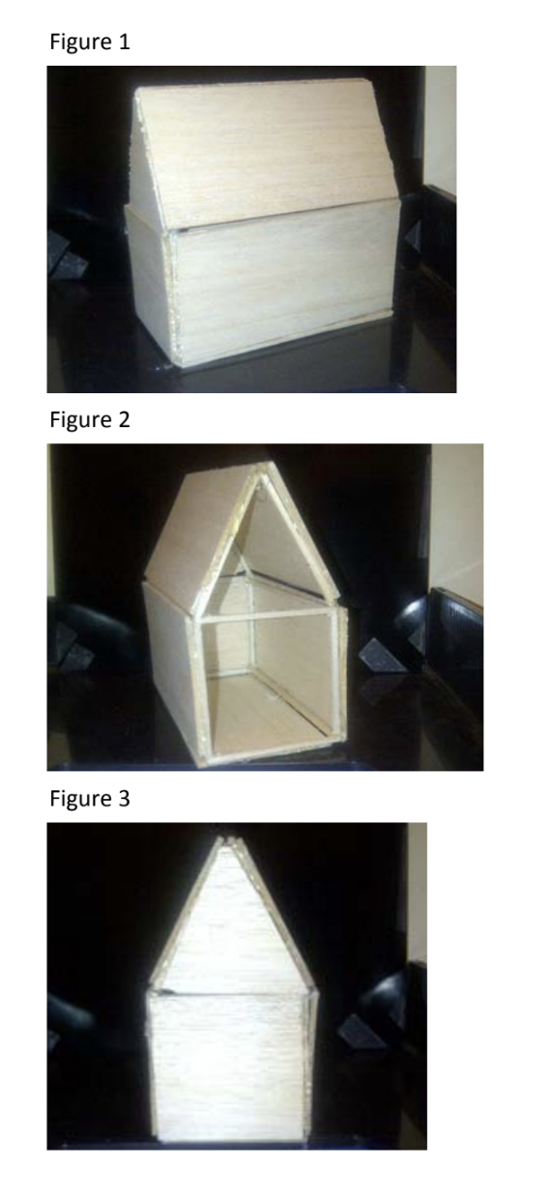

Wrap-up
End the lesson with some final discussions about what students designed/discovered. Connect their activity back to the focus question/problem, real world examples, and STEM careers.

Also include notes about any special cleanup considerations

Lesson Background for Teachers

Suggested Real-World STEM Connections
- List possible related Role Models in STEM (with details and links to more reading). Give suggestions for examples of scientists/engineers who are from underrepresented groups in STEM in related careers.
- List related real-world engineering problems and examples

Lesson Variations and Options
Include descriptions of alternative methods or ways to present things.

Explanation
Describe the background concepts and explanations behind the lesson. This can be more in depth than a teacher/instructor would actually share with students.

Key Concepts and Vocabulary
- Word 1: Grade Appropriate Definition
- Word 2: Grade Appropriate Definition

Safety Notes
- Safety instruction

